 |  | American International University-Bangladesh (AIUB)  Faculty of Engineering (FE)  Department of Electrical and Electronic Engineering (EEE)
Course Name: |  |  |  | Microprocessor and Embedded Systems | Course Code: |  | COE3104
Semester: |  |  |  | Spring 2025-2026 | Section:
Faculty Name:
Capstone Project Title: |  |  |  | Arduino-Based Gas Leakage and Fire Detection System With Prevention and Safety Mechanisms
Project Group #: |  |  |  | 0
SL # | ID |  | Student Name |  |  | Contribution |  | Marks
1 |  |  |  |  |  | 100%
2 |  |  |  |  |  | 100%
3 |  |  |  |  |  | 100%
4 |  |  |  |  |  | 100%
5 |  |  |  |  |  | 100%

Assessment Materials and Marks Allocation:
COs | Assessment Materials | POIs | Marks
CO2 | Course Project Report (Analyze a combinational/sequential logic circuit through appropriate survey of research literature to provide valid conclusion acknowledging the limitations.) | P.d.2.C4 | 20

COs | Excellent to Proficient  [16-20] | Good  [11-15] | Acceptable  [5-10] | Unacceptable  [1-4] | No Response  [0] | Secured Marks
CO2  P.d.2.C4 | The outcome of the project demonstrates a course project using logic ICs, transistors, switches, display devices, etc. that can solve a complex engineering problem in the electrical and electronic engineering discipline through appropriate research. | The outcome of the project somewhat demonstrates a course project using logic ICs, transistors, switches, display devices, etc., and also somewhat solves a complex engineering problem in the electrical and electronic engineering discipline through some research. | The outcome of the project demonstrates a course project using logic ICs, transistors, switches, display devices, etc. but cannot solve a complex engineering problem properly in the electrical and electronic engineering discipline through appropriate research. | The outcome of the project does not demonstrate a course project using logic ICs, transistors, switches, display devices, etc. also could not solve a complex engineering problem in the electrical and electronic engineering discipline through appropriate research. | No Response at all
Comments |  |  |  |  | Total Marks (20)

Arduino-Based Gas Leakage and Fire Detection System With Prevention and Safety Mechanisms

ddd
Department of Computer Science and Engineering (CSE)
American International University-Bangladesh (AIUB)
Dhaka, Bangladesh
Department of Computer Science and Engineering (CSE)
American International University-Bangladesh (AIUB)
Dhaka, Bangladesh
Department of Computer Science and Engineering (CSE)
American International University-Bangladesh (AIUB)
Dhaka, Bangladesh
Department of Computer Science and Engineering (CSE)
American International University-Bangladesh (AIUB)
Dhaka, Bangladesh
Najiat Islam Rishad
Department of Computer Science and Engineering (CSE)
American International University-Bangladesh (AIUB)
Dhaka, Bangladesh
23-55218-3@student.aiub.edu

Abstract —This paper presents the design and development of a low-cost, real-time gas leakage and flame detection system using Arduino for domestic and industrial safety applications. The system integrates an MQ-2 gas sensor for combustible gas detection and an infrared flame sensor to identify fire hazards. A buzzer and indicator LED are used as immediate alert mechanisms, while a 16×2 LCD displays real-time status messages. Additionally, There is also an exhaust fan which is automatically activated when the gas is detected to ventilate and the gas supply is turned off to avoid further leakages. The project aims to reduce the risk of accidents due to the leakage of gases or fire by detecting them in time and providing a quick alert and automatic safety response. The system follows a threshold-based monitoring approach where sensor data are continuously sampled and processed using a microcontroller. Experimental testing demonstrates reliable hazard detection and consistent alarm triggering under simulated leakage and flame conditions. Other effective automatic control measures that are exhibited by the system include ventilation and gas shutoff in case of dangerous circumstances. The proposed solution ensures operational simplicity, affordability, and adaptability for real-world environments. Future enhancements may include wireless notification features and IoT-based monitoring.
Keywords— Arduino, Gas leakage detection, Flame sensor, Embedded system, Safety monitoring, Real-time alert

- INTRODUCTION
A. Background of Study and Motivation
Gas leakage and accidental fire incidents pose severe threats to households, restaurants, laboratories, and industrial facilities. Explosions and fire outbreaks due to undetected gas accumulation may lead to loss of life, property damage, and environmental hazards. Conventional gas detection systems are often expensive and inaccessible for low-income communities.

Therefore, developing an affordable and reliable microcontroller-based safety solution is an essential engineering challenge. The proposed project covers this requirement by coming up with a small gas and flame detector and preclusion system with Arduino and cheap sensors, with automatic ventilation and gas supply shutoff systems.
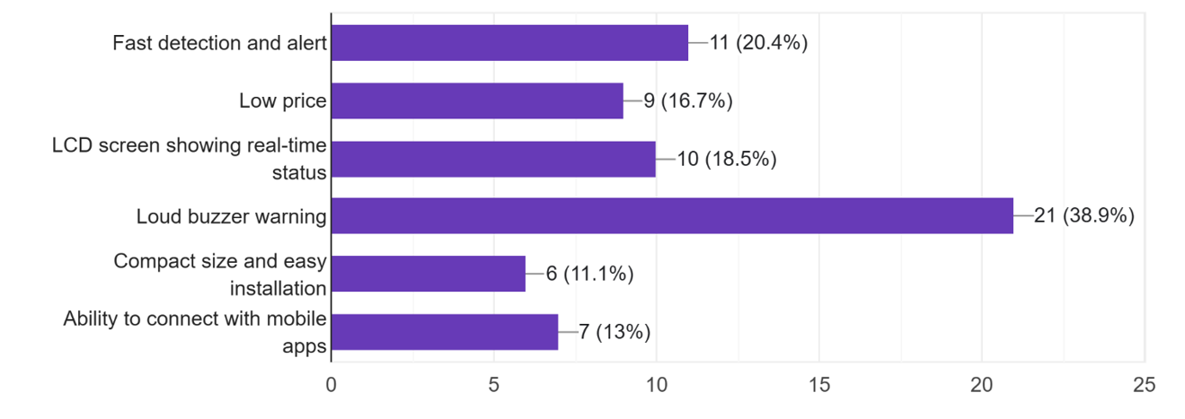
Figure 1: Preferred Device Features
Figure illustrates the survey-based analysis of user preferences and safety concerns related to gas leakage and fire detection devices. The results indicate that 77.7% of respondents expressed high concern regarding gas leakage and fire hazards, highlighting the strong demand for effective safety solutions. Additionally, 70.4% of participants reported that they currently do not use any gas or fire detection device, which reveals a significant gap between safety awareness and practical implementation.
The figure also shows that 42.6% of users are only willing to pay less than 1500 BDT, emphasizing the importance of affordability in system design. Furthermore, 38.9% of respondents prioritized a loud buzzer warning as the most important feature, indicating that immediate local alerts are preferred over complex or remote notification systems. These findings directly influenced the design decisions of the proposed system, such as the use of a buzzer, LED indicators, and low-cost components, ensuring alignment with user expectations and economic constraints. Also, the system has automatic exhaust fans and gas supply shutoff to increase safety over and above the basic alert systems.
Metric | Survey Result | Implication
Problem Demand (High Concern) | 77.7% (Concerned/Very Concerned) | Confirms strong psychological and safety need for the device.
Market Gap (No Device Used) | 70.4% (Do Not Use a Device) | Confirms a massive, untapped market for a new solution.
Price Constraint (Max Willingness) | 42.6% (Willing to pay < 1500 BDT) | Sets a strict design requirement for component cost and final pricing.
Key Feature Priority | 38.9% (Loud Buzzer Warning) | Directs the design focus toward immediate, local hazard notification.
The table presented in the Introduction section summarizes key survey metrics and their design implications. Each metric directly supports the motivation and objectives of the proposed project. The high percentage of users expressing concern confirms the necessity of a safety monitoring system, while the absence of existing devices among most respondents highlights a substantial market opportunity.
The identified price constraint establishes a clear limitation on component selection, ensuring the system remains affordable for domestic users. Moreover, the use of a loud buzzer as a priority justifies the use of audio-visual alert systems as the main response to the issue, as well as automated safety measures, including ventilation and gas shutdown. Overall, the table provides quantitative justification for the system requirements and ensures consistency between user needs and system design.

B. Project Objectives
The major objectives of the project are:
- To design a real-time gas and flame detection system using Arduino-based hardware.
- To generate immediate audio-visual alerts and display system status on an LCD screen during hazardous conditions.
- To implement automatic safety mechanisms including exhaust fan activation and gas supply shutoff.
- To evaluate the performance of the prototype through experimental testing.
C. Outline of the Report
Section II presents the literature review. Section III explains the methodology, working principle, and hardware components. Section IV discusses results and performance evaluation. Sections V and VI conclude the work and propose future extensions.

- LITERATURE REVIEW
Embedded system–based hazard monitoring using gas and flame sensors has become an essential research field due to the increasing rate of domestic and industrial fire accidents. Recent studies between 2022 and 2025 highlight the integration of microcontrollers, gas sensors, flame sensors, automated alerts and embedded real-time safety monitoring as a reliable approach for accident prevention. The reviewed literature demonstrates significant improvements in cost-effectiveness, accuracy, and early-warning capabilities, yet also reveals several research gaps that motivate the development of this project.
Kumar and Patel (2022) developed a low-cost fire detection system using a microcontroller-based flame sensor network. Their work emphasized the importance of early flame identification and highlighted that rapid alert response significantly reduces fire damage. However, the system primarily focused on flame detection and did not integrate gas leakage monitoring, which is a critical factor in explosion-related accidents. This limitation supports the need for a combined gas-and-flame dual-sensor approach, as implemented in the proposed project.
Uddin et al. (2024) introduced a smart home safety monitoring system using Arduino and IoT connectivity. Their system transmitted alerts through wireless communication platforms to notify users remotely. While IoT-based alerting adds technological advantages, it also increases system cost and dependency on network availability. The findings from this study align with the survey analysis of the present project, which revealed that users prioritize immediate local alerts (buzzer and LED) rather than cloud-based features due to affordability and reliability concerns.
Tanvir and Chowdhury (2023) designed an embedded LPG and methane leakage alert system for domestic applications. Their work demonstrated that MQ-series gas sensors are effective for monitoring combustible gases in indoor environments. However, they also highlighted issues such as false triggering due to environmental variations, emphasizing the importance of proper calibration and threshold tuning. The present project incorporates this insight by performing sensor testing and threshold validation through simulation and hardware experiments before implementation.
Singh et al. (2022) proposed a multi-sensor fire and gas detection system for smart buildings, integrating multiple sensing modules to enhance detection reliability. Their study recognized that combining sensors improves hazard identification accuracy compared to single-sensor systems. This supports the combined MQ-2 gas sensor and flame sensor architecture used in the proposed system, which increases safety response efficiency.
Park and Lee (2022) investigated real-time fire detection using flame sensors and edge-based processing, demonstrating rapid response with minimal latency. Their findings reinforce the importance of microcontroller-based local processing, where alerts are executed directly by the hardware without reliance on external communication or servers—one of the core design motivations of this project.
Across these studies, several common trends emerge:
- emphasis on low-cost safety systems,
- increasing adoption of Arduino-based embedded monitoring,
- focus on sensor-based early hazard detection, and
- integration of automatic alerting mechanisms.

Citation & Year | Embedded/IoT Focus | Key Contribution
[1] Mustofa, (2025). Design an Internet of Things-Based LPG Gas Leak Detection System. | NodeMCU, MQ-6 Sensor, Blynk (IoT) | Developed an IoT system using MQ-6 and NodeMCU, achieving an error value of 9.52% in gas detection and 500m distance for smartphone alerts.
[2] Ghasemi, S. M. et al. (2025). Reliability and Performance Evaluation of IoT-Based Gas Leakage Detection Systems for Residential Environments. | Dual-Sensor (VOC/Pellistor), BLE, LoRa, Reliability Testing | Focuses on reliability validation under stress and the use of dual-sensor strategy to optimize power consumption in power-intensive pellistor sensors.
[3] Baballe, M. A. et al. (2022). A Comparative Study on Gas Alarm Detection System. | ESP Controller, MQ-5 Sensor, Notification via Email/App | Comprehensive review of gas alarm systems, emphasizing the need for fast messaging and reliable notification to the user's mobile device.
[4] Alao, P. O. et al. (2024). Integrated Gas Leakage Detection and Automatic Shutoff System for Safety and Emergency Response. | ESP32, MQ-2, Flame Sensor, Servo Motor (Automatic Shutoff) | Integrated gas, fire, and temperature sensors with a servo motor for automatic gas line shutoff, showing a trend toward automated mitigation.
[5] Arfianto, R. et al. (2025). Gas Leakage Detection Using Tiny Machine Learning (TinyML). | Arduino Nano 33 BLE, Edge-based Processing (TinyML) | Proposed a TinyML solution to move data processing to the edge, significantly reducing latency and power consumption for real-time response.

The table included in the Literature Review section presents a comparative analysis of recent gas leakage and fire detection systems based on year, technology, sensors used, and key contributions. This comparison highlights current research trends, such as the increasing use of IoT platforms, dual-sensor integration, and edge-based processing for safety monitoring.
While many existing systems focus on IoT-based remote alerting and advanced automation, the table also reveals notable limitations, including higher system cost, network dependency, and increased complexity. These limitations contrast with the findings of the user survey discussed earlier, where affordability and immediate local alerts were identified as primary user requirements.
By comparing previous research with the proposed system, the table clearly demonstrates how this project addresses existing research gaps. Unlike IoT-dependent solutions, the proposed Arduino-based system emphasizes low cost, simplicity, and real-time local alerting, making it more suitable for domestic environments and budget-constrained communities. Moreover, the addition of a servo-motor to automatically cut off gas supply and an exhaust fan to maintain a safe atmosphere contributes to the safety of the system, actively preventing the development of hazards.
However, gaps remain in affordable, simple, and locally deployable domestic safety devices, especially for communities with budget constraints The proposed project directly fills these gaps by creating a cost-effective Arduino-based gas and flame detector system with real-time alerts and automated gas response, such as the activation of exhaust fans and the use of a servo motor-controlled gas shutoff, which was tested and validated by simulation and experimentation.

- METHODOLOGY AND MODELING
A. Introduction
The system measures the concentration of the combustible gas and the presence of flames, compares the read values to pre-established values, and triggers the alert and safety systems in case of the detection of dangerous situations.
B. Working Principle of the Proposed System
The MQ-2 sensor provides an analog signal which is proportional to gas density. At the point of the gas concentration being larger than the limit, the Arduino turns on the buzzer and LED and shows an alert on the LCD. Meanwhile, ventilation is provided by turning on the exhaust fan, and a servo motor is engaged to close the gas cylinder valve.
The flame sensor works on the principle of detecting infrared radiation and giving notifications when a flame source is detected within the field of view. Both sensors are used at the same time so that hazards are well monitored.
C. Process of Work
The prototype was developed through incremental stages: circuit design, sensor calibration, Arduino programming, and experimental testing. Sensor readings were observed under normal and hazardous conditions to ensure accurate response behavior. Threshold values were tuned based on repeated trials to minimize false alarms.

D. Description of Components
- Arduino Uno R3 (1 pc)
- MQ-2 Gas Sensor (1 pc)
- Flame Sensor Module (1 pc)
- Active Buzzer (1 pc)
- Red LED (1 pc)
- 220Ω Resistors – 2 pcs
- Breadboard (1 pc)
- Jumper Wires (20–30 pcs)
- USB Power Cable (1 pc)
- Servo Motor (1 pc)
- Mosfet (1 pc)
- Exhaust Fan (1 pc)

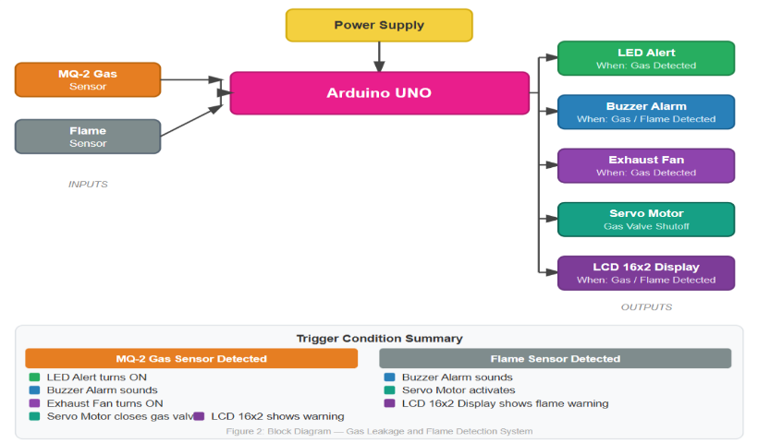
E. Experimental Setup
Figure 2: Block Diagram — Gas Leakage and Flame Detection System
The block diagram presented in the Experimental Setup section illustrates the overall architecture and data flow of the proposed gas leakage and flame detection system. The system consists of sensing, processing, and alerting modules interconnected through the Arduino microcontroller.
The MQ-2 gas sensor continuously monitors combustible gas concentration, while the flame sensor detects infrared radiation emitted by fire sources. The analog and digital outputs from these sensors are fed into the Arduino Uno, which serves as the central processing unit. The microcontroller compares the sensor readings with predefined threshold values to determine the presence of hazardous conditions.
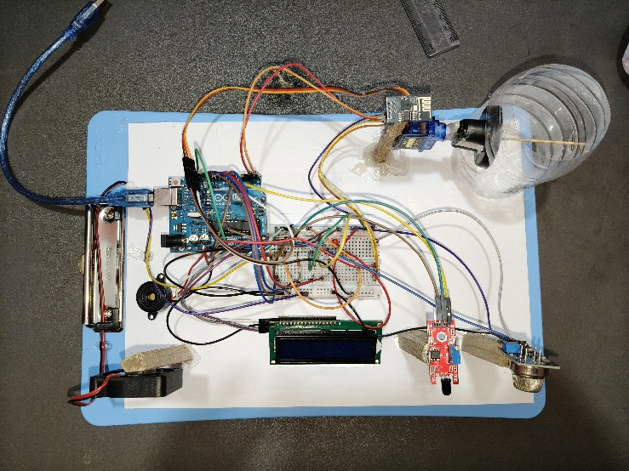
Once the abnormal gas concentration or flame is sensed, then the Arduino triggers the buzzer and LED to create audio-visual feedback. At the same time, the exhaust fan is activated to force the air out of the space and the servo motor spins to shut the gas cylinder valve, eliminating additional leakage. The 16x2 LCD displays relevant warning messages that help users to have an idea of the type of hazard detected in real time..This block diagram effectively links the system’s hardware components with its operational logic and supports the methodology described in earlier sections.
Figure 3: Prototype Implementation of the Gas Leakage and Flame Detection System
The system was experimented in a laboratory. Simulation of gas leakage was done through exposure to controlled exposure of butane and flame detection was confirmed by a safe lighter flame at different distances. The sensor outputs, fan activation, servo shutoff action and the alert responses were measured and analyzed.

- RESULTS AND DISCUSSIONS
A. Numerical Analysis
Preliminary evaluation confirmed expected sensor behavior and threshold crossing patterns. Simulated values helped calibrate detection limits before physical testing.
Test Condition | Gas Value (ADC) | Flame Status | System Output
Normal Room Air | 320–360 | No Flame | SAFE – No Alarm
Mild Gas Presence | 380–420 | No Flame | Threshold Near – Warning Display
Gas Leak Condition | 450–600 | No Flame | Buzzer ON, LED Blinking, Fan ON, Servo Shutoff,  LCD = GAS ALERT
Flame Detected | — | LOW (Detected) | Buzzer ON, LED Blinking, LCD = FLAME ALERT
Gas + Flame Together | >450 | LOW | Emergency Alert – Continuous Alarm, Fan ON, Servo Shutoff
A preliminary numerical analysis was conducted to evaluate the expected behavior of the gas and flame sensors before physical experimentation. Simulated sensor readings were analyzed to identify threshold crossing patterns under different environmental conditions. The MQ-2 gas sensor exhibited stable analog-to-digital converter (ADC) values ranging between 320 and 360 in normal room air, which was considered a safe operating condition.
When a mild presence of combustible gas was introduced, the sensor output increased to a range of 380–420 ADC, indicating proximity to the predefined threshold. In this state, the system generated a warning message on the LCD without activating the alarm, allowing early awareness before a hazardous condition occurred. The gas sensor readings during the simulated gas leakage condition were more than 450 ADC, which turned on the buzzer and blinking LED, turned on the exhaust fan and switched off the gas cylinder using the servo motor with a message of GAS ALERT being displayed on the LCD.
Similarly, the flame sensor demonstrated a reliable response by outputting a LOW signal when a flame source was detected. In scenarios where both gas leakage and flame were present simultaneously, the system entered an emergency state, activating a continuous alarm, exhaust fan, and servo-based gas shutoff to indicate and prevent a critical hazard.
These numerical data offered a useful starting point to calibration of the threshold values and testing the logic of the responses of the buzzer, fan, and servo motor before the experimentation.

B. Experimental Results
Experimental testing was performed in a controlled laboratory environment to validate the numerical analysis. Gas leakage was simulated using controlled butane exposure, and flame detection was verified using a lighter flame placed at varying distances from the sensor. The system was able to sense the presence of gas exceeding the threshold, and trigger the alarm and safety systems, consisting of the buzzer, exhaust fan, and the servo-controlled gas shutdown mechanism, in a few seconds.
Flame detection showed minimal latency, and the system reliably responded to infrared radiation emitted by the flame source. When the hazard was detected, the buzzer and LED were triggered, and the exhaust fan was turned on and the servo motor automatically closed the gas cylinder. The LCD showed real-time warning messages which were clear and correct. These results confirm that the proposed system performs effectively under practical operating conditions.

C. Comparison between Numerical and Experimental Results
A comparison between simulated (numerical) results and experimental outcomes reveals strong agreement in system behavior and response patterns. Threshold crossing trends observed during numerical analysis closely matched the measured sensor outputs during physical testing. Minor variations in response time and sensor readings were observed, primarily due to environmental factors such as airflow, ambient temperature, and sensor tolerance.
Nevertheless, the system had small deviations but was consistent in its hazard detection, alert activation, and automatic safety response action, which proved to be robust and reliable. The fact that the numerical and experimental data are closely correlated proves the accuracy of the threshold-based monitoring method and the efficiency of the integrated safety response system, such as the work of fans and servo-based gas shutoff.

D. Cost Analysis
The proposed gas leakage and flame detection system was developed using low-cost and widely available electronic components. The total cost of the prototype is significantly lower than that of commercially available gas and fire detection systems. This cost-effectiveness makes the system suitable for domestic households, small restaurants, and low-income communities where expensive safety devices are often inaccessible.
The affordability of the system directly aligns with the survey findings discussed earlier, where users expressed strong price sensitivity and a preference for simple, locally operable safety solutions.

E. Limitations of the Project
Despite the fact that the system is reliable, it lacks wireless communication and thus the users are not able to get remote alerts on their cell phones. IoT functionality can be implemented in the future to provide notifications in real-time.
The present system involves a servo motor to close the gas, and this would be appropriate to close the gas in a prototype. To be more practical, a more powerful solution like a solenoid valve may be applied to have more secure and powerful gas control.
Also, sensor behavior can be different in extreme environmental conditions which may have a minor influence on detection accuracy.
- CONCLUSION
The developed gas leakage and flame detection system successfully demonstrates a low-cost, reliable, and real-time safety monitoring solution suitable for households and small commercial environments. Combining the MQ-2 gas sensor and flame sensor with an Arduino-based control unit allows the system to automatically monitor dangerous conditions and provide instant audio-visual feedback with a buzzer and LED indicators, and run an exhaust fan to ventilate the casing, as well as to automatically turn off the gas cylinder with a servo motor. Experimental testing confirms that the system responds quickly and consistently when gas concentration exceeds the threshold or a flame is detected.
The findings from the project indicate that the proposed system can significantly reduce accident risk, enhance user safety awareness, and provide early warning before critical hazard escalation. Unlike expensive commercial detectors or cloud-dependent IoT platforms, this system remains affordable, simple, and locally operational, making it suitable for general domestic users, especially in resource-constrained communities.
Overall, the project demonstrates that Hazard detection and prevention embedded systems can be significant in providing a safer household environment by not only detecting hazards, but acting immediately to mitigate risk.

- FUTURE SCOPE
Although the system performs effectively in its current form, several enhancements may further improve functionality and applicability:
- IoT-Based Remote Alerting
Integration of GSM, Wi-Fi, or mobile app notification features may allow users to receive alerts remotely when they are away from home.
- Automatic Gas Shut-Off Mechanism
To make the gas control in the real world applications safer and more effective, the current servo motor can be substituted with a more powerful and sound actuator like solenoid valve or industrial-level shutoff system. Combinations with Home Automation Systems.
- Battery Backup and Portable Design
A rechargeable power system can keep the device operational during power failure, increasing reliability in emergency conditions.
- The system can be extended to smart home networks to be integrated with the existing safety systems like ventilation control and appliance shutdown based on the relays in a smart home system.
- Enhanced Sensor Calibration and Environmental Adaptability
Future versions may incorporate filtering algorithms to minimize false alarms and improve stability across humidity and airflow variations.
These extensions will enhance the system’s robustness, safety automation capability, and real-world usability.

- REFERENCES
- S. Kumar and V. Patel, “Low-Cost Fire Detection Using Microcontroller and Flame Sensor Network,” IEEE Access, vol. 10, pp. 115230–115240, 2022.
- M. Uddin, R. Chowdhury, and K. Hossain, “Smart Home Safety Monitoring System Using Arduino and IoT,” Proc. IEEE Int. Conf. Computing, Electronics and Communications Engineering (ICCECE), 2024, pp. 556–561.
- H. Tanvir and N. Chowdhury, “Embedded LPG and Methane Leakage Alert System for Domestic Applications,” IEEE Region 10 Symposium (TENSYMP), 2023, pp. 102–107.
- [4] R. Singh, M. Das, and P. Roy, “Design of a Multi-Sensor Fire and Gas Detection System for Smart Buildings,” Proc. IEEE Int. Conf. Intelligent Systems (IS), 2022, pp. 844–850.
- J. Park and J. Lee, “Real-Time Fire Detection Using Flame Sensors and Edge Computing,” IEEE Internet of Things Journal, vol. 9, no. 12, pp. 9510–9521, 2022.
- A. Rahman, M. A. Islam, and S. Ahmed, “Design and Implementation of an Arduino-Based Gas Leakage Detection System for Domestic Safety,” International Journal of Engineering Research & Technology (IJERT), vol. 12, no. 3, pp. 410–415, 2023.
- M. H. Hossain and T. Rahman, “Low-Cost Embedded Fire Detection System Using Flame and Smoke Sensors,” International Journal of Embedded Systems and Applications, vol. 11, no. 2, pp. 21–30, 2022.
- N. S. Hasan, M. R. Alam, and F. Karim, “Microcontroller-Based Real-Time Gas Monitoring System for Household Safety,” Journal of Sensor Technology, vol. 9, no. 1, pp. 45–53, 2023.
- P. Gupta and S. Verma, “Performance Analysis of MQ-Series Gas Sensors for LPG and Methane Detection,” IEEE Sensors Journal, vol. 22, no. 18, pp. 17840–17847, 2022.
- M. Al-Hassan and K. Youssef, “Design of a Standalone Gas and Fire Detection System Using Arduino,” Procedia Computer Science, vol. 210, pp. 152–159, 2022.

